Supplementary information
Improving production of Streptomyces griseus trypsin for its application in processing insulin precursor

Yunfeng Zhang^{1, 2,3}, Qixing Liang¹, Chuanzhi Zhang⁴, Juan Zhang¹, Guocheng Du^{1, 2} & Zhen Kang^{1, 2}*
¹Key Laboratory of Industrial Biotechnology, Ministry of Education, Jiangnan University, 1800 Lihu Road, Wuxi, Jiangsu 214122, China;
²The Key Laboratory of Carbohydrate Chemistry and Biotechnology, Ministry of Education, School of Biotechnology, Jiangnan University, Wuxi 214122, China
³Center for Synthetic Biochemistry, Institute of Synthetic Biology, Shenzhen Institutes of Advanced Technologies, Shenzhen, China.
⁴Bio-Pharmaceutical Research Institute Lian Yun Gang, Chia Tai Tianqing Pharmaceutical Group Co., Ltd., Lianyungang, Jiangsu, China.
*Correspondence and requests for materials should be addressed to Z.K. (email: zkang@jiangnan.edu.cn).

Supplementary Table 1. Oligonucleotides used in this study
Primer name | Sequence of primer (5'→3')
FR21I | ATTGCCGCCCAGGGCGAGTT
FR21L | TTGGCCGCCCAGGGCGAGTT
FR21E | GAAGCCGCCCAGGGCGAGTT
FR21G | GGTGCCGCCCAGGGCGAGTT
FR21P | CCAGCCGCCCAGGGCGAGTT
FR21M | ATGGCCGCCCAGGGCGAGTT
FR21V | GTTGCCGCCCAGGGCGAGTT
RR21 | GGTTCCGCCGACGACGAA
FR32A | GCTCTCTCCATGGGCTGCGG
FR32G | GGTCTCTCCATGGGCTGCGG
FR32S | TCTCTCTCCATGGGCTGCGG
FR32F | TTTCTCTCCATGGGCTGCGG
FR32Y | TACCTCTCCATGGGCTGCGG
FR32W | TGGCTCTCCATGGGCTGCGG
RR32 | GACCATGAAGGGGAACTCG
FK122A | GCTATCGCCACCACCACCGC
FK122I | ATTATCGCCACCACCACCGC
FK122L | TTGATCGCCACCACCACCGC
FK122E | GAAATCGCCACCACCACCGC
FK122V | GTTATCGCCACCACCACCGC
FK122Y | TACATCGCCACCACCACCGC
RK122 | CAGCGTGGGCTGGTTGATG
FR153I | ATTTACCTGCTCAAGGCCAACGTC
FR153L | TTGTACCTGCTCAAGGCCAACGTC
FR153V | GTTTACCTGCTCAAGGCCAACGTC
FR153P | CCATACCTGCTCAAGGCCAACGTC
FR153H | CATTACCTGCTCAAGGCCAACGTC
FR153A | GCTTACCTGCTCAAGGCCAACGTC
RR153 | CTGCTGGCTGCCGCCCT
FR201I | ATTAAGGACAACGCCGACGAGT
FR201L | TTGAAGGACAACGCCGACGAGT
FR201F | TTTAAGGACAACGCCGACGAGT
FR201V | GTTAAGGACAACGCCGACGAGT
FR201W | TGGAAGGACAACGCCGACGAGT
FR201E | GAAAAGGACAACGCCGACGAGT
FR201Y | TACAAGGACAACGCCGACGAGT
FR201S | TCTAAGGACAACGCCGACGAGT
FR201N | CAAAAGGACAACGCCGACGAGT
FR201G | GGTAAGGACAACGCCGACGAGT
FpGAPZB | GGTACCTCGAGCCGCGGC
RpGAPZB | CGTTTCGAAGTTGTTCAATTG
RR201 | GAACATCGGGCCGCCG
FERO1 | CTTCGAAACGATGAGGATAGTAAGGAGC
RERO1 | AGGTACCTTACAAGTCTACTCTATATGTGG
FPDI | CTTCGAAACGATGCAATTCAACTGGAATATTAAAACTGTG
RPDI | AGGTACCTTAAAGCTCGTCGTGAGCGTC
FUBC1 | CTTCGAAACGATGACTAGCATTAAACGAATC
RUBC1 | AGGTACCTTATCTCAAAAGCTCTTCTAAAATTTC
FGSH2 | CTTCGAAACGATGATGTTCCCCTTTCGTAG
RGSH2 | AGGTACCTTAGAAAAGATAAACGCTGTCAAC
FGLR1 | CTTCGAAACGATGCCCTCAATTGCCCAG
RGLR1 | AGGTACCTTAAACCATTGTCACTAATTCTTCAGC
FHSP90 | CTTCGAAACGATGTCAAAGTCCGAATCGTAC
RHSP90 | AGGTACCTTAGTCAACCTCCTCCATGGC
FBIP | CTTCGAAACGATGTTTTTCAACAGACTAAGC
RBIP | AGGTACCTTACAATTCGTCGTGTTCGAAATAATC
FSEC53 | CTTCGAAACGATGTCGTTTTCTAATAAAGAAGATC
RSEC53 | AGGTACCTTACAGGGAAAAGAGCTCCTTTAAG
FSLY1 | CTTCGAAACGATGCTTCATTTGAATGAGCCC
RSLY1 | AGGTACCTTATTTTGCTTCGGCACCGAG
FSEC1 | CTTCGAAACGATGGCTTCTGATCTGATTAAC
RSEC1 | AGGTACCTTATTTCCAAAATTTCTTCAGC
FSSO2 | CTTCGAAACGATGAGTAACCAGTATAATCCGTATG
RSSO2 | AGGTACCTTATCTTCCCCAGTTTCCGAC
FpGAPmAvrII | GTTACCGTCCTTAGGAAATTTTACTCTGC
RpGAPmAvrII | GGGCGGTGGAAGGAGAGA
FpGAPm | GTACAGAAGATTAAGTGAGAAAGAGTTGGTAGCTCTTG
RAOX1 | GGGATCCGCACAAACGAAGGTCTCACTTAATCTTCTGTACTC
FpGAP-C | CCTTCGTTTGTGCGGATC
RpGAP-C | TCTCACTTAATCTTCTGTACTC
FpGAPm-UBC1 | GTGAGACCTTCGTTTGTGCGGATCCCTCAAGAAGATCCTTTGATC
RpGAPm-UBC1 | TGAAGCTATGGTGTGTGGGGGATCCCAAACGAAGGTCTCACTTAATC
Fsgt | ACACTGGTGGCGTTGATAC
Rsgt | CGATGCCGACCTGAATCC
Fgapdh | ACAAGGACTGGAGAGGTGGTAG
Rgapdh | CGGTTGGGACACGGAAAGC

Supplementary Table 2. The Plasmids and strains used in this study
Plasmids or strains | Genotype | Reference
Plasmids
pPIC9K | HIS Amp^{r} or Kan^{r} | Invitrogen
pPIC9K-tbcf (K101A) | pPIC9K derivative containing P_{AOX1}-tbcf (K101A) expression cassette | ^{[1]}
pPIC9K-rSGT | pPIC9K derivative containing P_{AOX1}-rSGT | _{[2]}
pMD19-T-GAPDH | pMD19-T derivative containing the GAPDH gene | _{[2]}
pGAPZB | Expression plasmid with Zeocin selection marker | Invitrogen
Strains
E. coli JM109 | F´traD36 proA⁺B⁺ lacIq Δ(lacZ) M15/Δ(lac-proAB) glnV44e14- gyrA96 recA1 relA1 endA1 thi hsdR17 | NEB
GS115(wild type) | his4 Mut⁺ His⁻ (aox1⁺, aox2⁺) | Invitrogen
GS115-tbcf | GS115 his4∷P_{AOX1}-αMF(Δ57-70)-HL28-Ap-btc-EIF HIS, KAN | [1]
GS115-tbcf (K101A) | GS115 his4∷P_{AOX1}-αMF(Δ57-70)-HL28-Ap-btc-EIF (K101A) HIS, KAN | [1]
GS115-tbcf (K101A, R21P) | GS115 his4∷P_{AOX1}-αMF(Δ57-70)-HL28-Ap-btc-EIF (K101A, R21P) HIS, KAN | This study
GS115-tbcf (K101A, R21M) | GS115 his4∷P_{AOX1}-αMF(Δ57-70)-HL28-Ap-btc-EIF (K101A, R21M) HIS, KAN | This study
GS115-tbcf (K101A, R21V) | GS115 his4∷P_{AOX1}-αMF(Δ57-70)-HL28-Ap-btc-EIF (K101A, R21V) HIS, KAN | This study
GS115-tbcf (K101A, R21S) | GS115 his4∷P_{AOX1}-αMF(Δ57-70)-HL28-Ap-btc-EIF (K101A, R21S) HIS, KAN | This study
GS115-tbcf (K101A, R21L) | GS115 his4∷P_{AOX1}-αMF(Δ57-70)-HL28-Ap-btc-EIF (K101A, R21L) HIS, KAN | This study
GS115-tbcf (K101A, R21E) | GS115 his4∷P_{AOX1}-αMF(Δ57-70)-HL28-Ap-btc-EIF (K101A, R21E) HIS, KAN | This study
GS115-tbcf (K101A, R21I) | GS115 his4∷P_{AOX1}-αMF(Δ57-70)-HL28-Ap-btc-EIF (K101A, R21I) HIS, KAN | This study
GS115-tbcf (K101A, R32A) | GS115 his4∷P_{AOX1}-αMF(Δ57-70)-HL28-Ap-btc-EIF (K101A, R32A) HIS, KAN | This study
GS115-tbcf (K101A, R32F) | GS115 his4∷P_{AOX1}-αMF(Δ57-70)-HL28-Ap-btc-EIF (K101A, R32F) HIS, KAN | This study
GS115-tbcf (K101A, R32S) | GS115 his4∷P_{AOX1}-αMF(Δ57-70)-HL28-Ap-btc-EIF (K101A, R32S) HIS, KAN | This study
GS115-tbcf (K101A, R32Y) | GS115 his4∷P_{AOX1}-αMF(Δ57-70)-HL28-Ap-btc-EIF (K101A, R32Y) HIS, KAN | This study
GS115-tbcf (K101A, R32W) | GS115 his4∷P_{AOX1}-αMF(Δ57-70)-HL28-Ap-btc-EIF (K101A, R32W) HIS, KAN | This study
GS115-tbcf (K101A, R32G) | GS115 his4∷P_{AOX1}-αMF(Δ57-70)-HL28-Ap-btc-EIF (K101A, R32G) HIS, KAN | This study
GS115-tbcf (K101A, K122A) | GS115 his4∷P_{AOX1}-αMF(Δ57-70)-HL28-Ap-btc-EIF (K101A, K122A) HIS, KAN | This study
GS115-tbcf (K101A, K122L) | GS115 his4∷P_{AOX1}-αMF(Δ57-70)-HL28-Ap-btc-EIF (K101A, K122L) HIS, KAN | This study
GS115-tbcf (K101A, K122I) | GS115 his4∷P_{AOX1}-αMF(Δ57-70)-HL28-Ap-btc-EIF (K101A, K122I) HIS, KAN | This study
GS115-tbcf (K101A, K122V) | GS115 his4∷P_{AOX1}-αMF(Δ57-70)-HL28-Ap-btc-EIF (K101A, K122V) HIS, KAN | This study
GS115-tbcf (K101A, K122Y) | GS115 his4∷P_{AOX1}-αMF(Δ57-70)-HL28-Ap-btc-EIF (K101A, K122Y) HIS, KAN | This study
GS115-tbcf (K101A, K122E) | GS115 his4∷P_{AOX1}-αMF(Δ57-70)-HL28-Ap-btc-EIF (K101A, K122E) HIS, KAN | This study
GS115-tbcf (K101A, R153A) | GS115 his4∷P_{AOX1}-αMF(Δ57-70)-HL28-Ap-btc-EIF (K101A, R153A) HIS, KAN | This study
GS115-tbcf (K101A, R153P) | GS115 his4∷P_{AOX1}-αMF(Δ57-70)-HL28-Ap-btc-EIF (K101A, R153P) HIS, KAN | This study
GS115-tbcf (K101A, R153I) | GS115 his4∷P_{AOX1}-αMF(Δ57-70)-HL28-Ap-btc-EIF (K101A, R153I) HIS, KAN | This study
GS115-tbcf (K101A, R153H) | GS115 his4∷P_{AOX1}-αMF(Δ57-70)-HL28-Ap-btc-EIF (K101A, R153H) HIS, KAN | This study
GS115-tbcf (K101A, R153V) | GS115 his4∷_{PAOX1}-αMF(Δ57-70)-HL28-Ap-btc-EIF (K101A, R153V) HIS, KAN | This study
GS115-tbcf (K101A, R153L) | GS115 his4∷P_{AOX1}-αMF(Δ57-70)-HL28-Ap-btc-EIF (K101A, R153L) HIS, KAN | This study
GS115-tbcf (K101A, R201V) | GS115 his4∷P_{AOX1}-αMF(Δ57-70)-HL28-Ap-btc-EIF (K101A, R201V) HIS, KAN | This study
GS115-tbcf (K101A, R201I) | GS115 his4∷P_{AOX1}-αMF(Δ57-70)-HL28-Ap-btc-EIF (K101A, R201I) HIS, KAN | This study
GS115-tbcf (K101A, R201S) | GS115 his4∷P_{AOX1}-αMF(Δ57-70)-HL28-Ap-btc-EIF (K101A, R201S) HIS, KAN | This study
GS115-tbcf (K101A, R201E) | GS115 his4∷P_{AOX1}-αMF(Δ57-70)-HL28-Ap-btc-EIF (K101A, R201E) HIS, KAN | This study
GS115-tbcf (K101A, R201N) | GS115 his4∷P_{AOX1}-αMF(Δ57-70)-HL28-Ap-btc-EIF (K101A, R201N) HIS, KAN | This study
GS115-tbcf (K101A, R201G) | GS115 his4∷P_{AOX1}-αMF(Δ57-70)-HL28-Ap-btc-EIF (K101A, R201G) HIS, KAN | This study
GS115-tbcf (K101A, R201W) | GS115 his4∷P_{AOX1}-αMF(Δ57-70)-HL28-Ap-btc-EIF (K101A, R201W) HIS, KAN | This study
GS115-tbcf (K101A, R201F) | GS115 his4∷P_{AOX1}-αMF(Δ57-70)-HL28-Ap-btc-EIF (K101A, R201F) HIS, KAN | This study
GS115-tbcf (K101A, R201L) | GS115 his4∷P_{AOX1}-αMF(Δ57-70)-HL28-Ap-btc-EIF (K101A, R201L) HIS, KAN | This study
GS115-tbcf (K101A, R201Y) | GS115 his4∷P_{AOX1}-αMF(Δ57-70)-HL28-Ap-btc-EIF (K101A, R201Y) HIS, KAN | This study
GS115-tbcf (K101A, R201V, R32A) | GS115 HIS∷P_{AOX1}-αMF(Δ57-70)-HL28-Ap-btc-EIF (K101A, R201V, R32A) HIS, KAN | This study
 |  | This study
GS115-tbcf (K101A, R201V)-Bip | GS115-tbcf (K101A, R201V); pGAP-Bip-TAOX1 HIS, KAN, Zeocin | This study
GS115-tbcf (K101A, R201V)-Hsp90 | GS115-tbcf (K101A, R201V); pGAP-Hsp90-TAOX1 HIS, KAN, Zeocin | This study
GS115-tbcf (K101A, R201V)-HAC1s | GS115-tbcf (K101A, R201V); pGAP-HAC1s-TAOX1 HIS, KAN, Zeocin | This study
GS115-tbcf (K101A, R201V)-Ero1 | GS115-tbcf (K101A, R201V); pGAP-Ero1-TAOX1 HIS, KAN, Zeocin | This study
GS115-tbcf (K101A, R201V)-SLY1 | GS115-tbcf (K101A, R201V); pGAP-SLY1-TAOX1 HIS, KAN, Zeocin | This study
GS115-tbcf (K101A, R201V)-SEC53 | GS115-tbcf (K101A, R201V); pGAP-SEC53-TAOX1 HIS, KAN, Zeocin | This study
GS115-tbcf (K101A, R201V)-SEC1 | GS115-tbcf (K101A, R201V); pGAP-SEC1-TAOX1 HIS, KAN, Zeocin | This study
GS115-tbcf (K101A, R201V)-SSO2 | GS115-tbcf (K101A, R201V); pGAP-SSO2-TAOX1 HIS, KAN, Zeocin | This study
GS115-tbcf (K101A, R201V)-GLR1 | GS115-tbcf (K101A, R201V); pGAP-GLR1-TAOX1 HIS, KAN, Zeocin | This study
GS115-tbcf (K101A, R201V)-PDI | GS115-tbcf (K101A, R201V); pGAP-PDI-TAOX1 HIS, KAN, Zeocin | This study
GS115-tbcf (K101A, R201V)-GSH2 | GS115-tbcf (K101A, R201V); pGAP-GSH2-TAOX1 HIS, KAN, Zeocin | This study
GS115-tbcf (K101A, R201V)-UBC1 | GS115-tbcf (K101A, R201V); pGAP-UBC1-TAOX1 HIS, KAN, Zeocin | This study
GS115-tbcf (K101A, R201V)_SS | GS115-tbcf (K101A, R201V); pGAP-SSO2-TAOX1; pGAP^{m}-SEC1-TAOX1 HIS, KAN, Zeocin | This study
GS115-tbcf (K101A, R201V)_SU | GS115-tbcf (K101A, R201V); pGAP-SSO2-TAOX1; pGAP^{m}-UBC1-TAOX1 HIS, KAN, Zeocin | This study
GS115-tbcf (K101A, R201V)_US | GS115-tbcf (K101A, R201V); pGAP-UBC1-TAOX1; pGAP^{m}-SEC1-TAOX1 HIS, KAN, Zeocin | This study
GS115-tbcf (K101A, R201V)_SSU | GS115-tbcf (K101A, R201V); pGAP-SSO2-TAOX1; pGAP^{m}-SEC1-TAOX1; pGAP^{m}-UBC1-TAOX1 HIS, KAN, Zeocin | This study
GS115-rPI | GS115-pAOX1-rPI-TAOX1 HIS, KAN | This study

Supplymentary Table 3. Kinetic parameters of tbcf and tbcf (K101A, R201V) mutant

Enzyme | K_{m} (mM) | k_{cat} (min⁻¹) | k_{cat}/K_{m}  （min¹·mM⁻¹）
tbcf | 5.86 ± 0.16×10⁻² | 7.20 ± 0.42×10⁵ | 1.23×10⁷
tbcf (K101A, R201V) | 5.39 ± 0.36×10⁻² | 8.24 ± 0.15×10⁵ | 1.53×10⁷

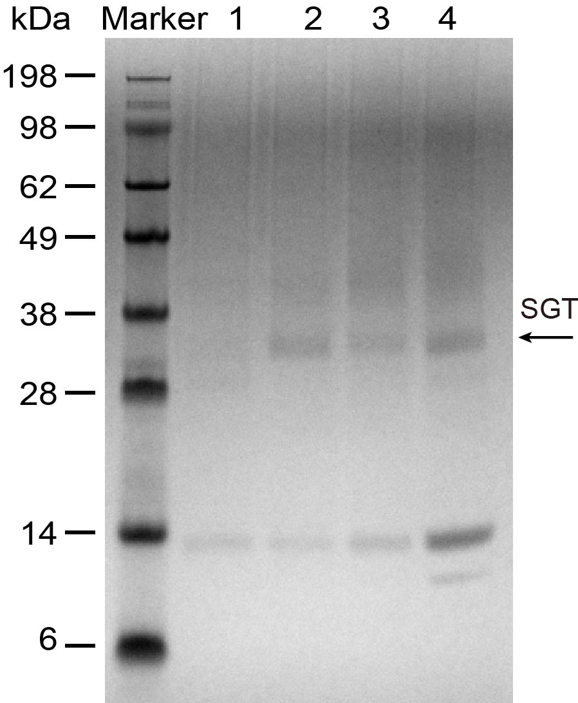
Supplementary Figure 1. SDS-PAGE of the culture supernatant. 1, tbcf (tbcf); 2, tbcf (K101A); 3, tbcf (K101A, R201V). 4, tbcf (K101A, R201V, R32A)

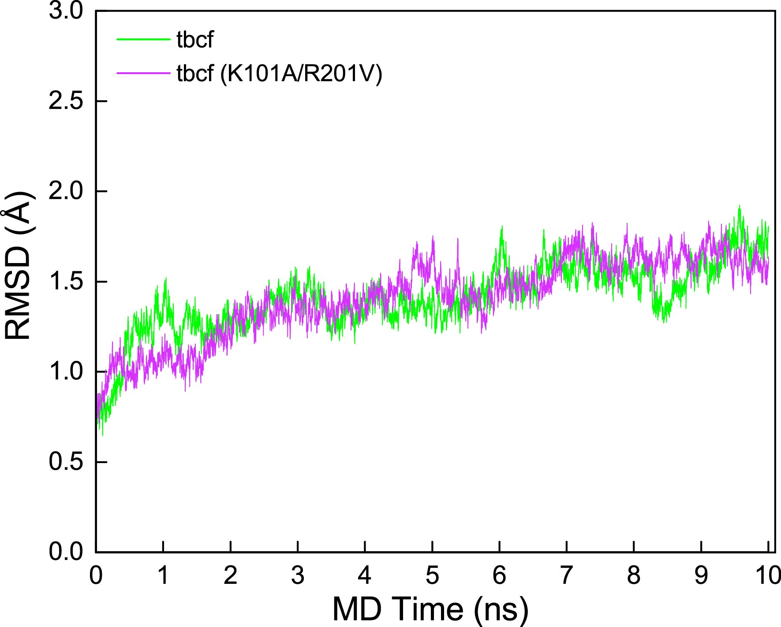
Supplementary Figure 2. The Root-mean-square deviation (RMSD) plot by molecular dynamics simulation.

REFERENCES
1. Zhang Y, Huang H, Yao X, Du G, Chen J, Kang Z: High-yield secretory production of stable, active trypsin through engineering of the N-terminal peptide and self-degradation sites in Pichia pastoris. Bioresour Technol 2017, 247:81-87.
2. Zhang Y, Ling Z, Du G, Chen J, Kang Z: Improved production of active Streptomyces griseus trypsin with a novel auto-catalyzed strategy. Sci Rep 2016, 6:23158.

